A) I)For a perfectly positively correlated portfolio when the investor increases the percentage of allocation to a particular project the slope of the line will still remain the same since the other project will in turn reduce to counter the effect.
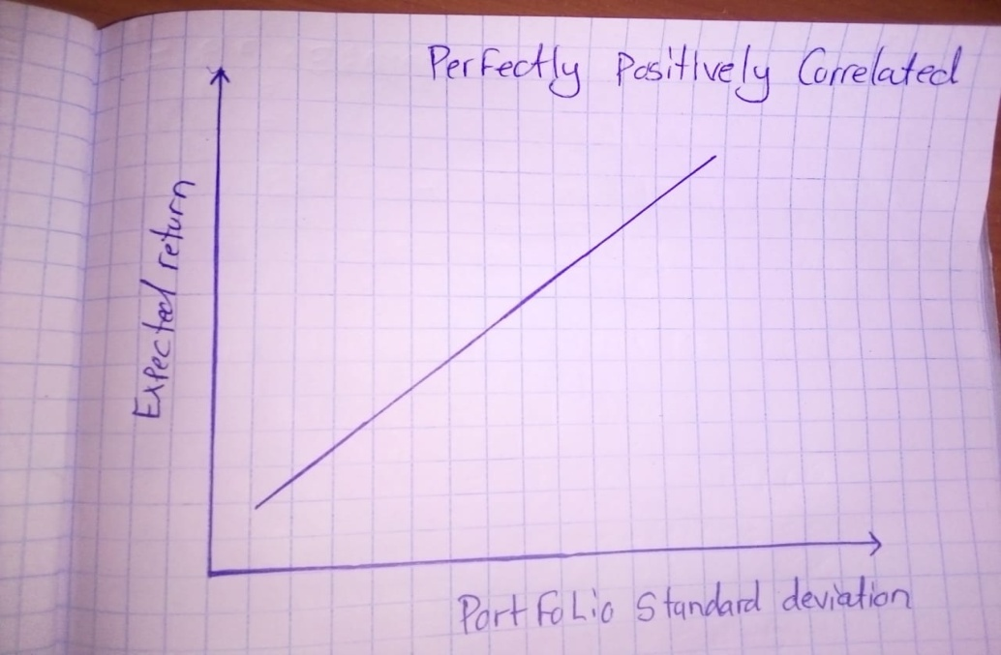

ii) For a perfectly negatively correlated project when the investor increases the percentage of allocation to a particular project the other will move downwards since the two projects are perfectly negatively correlated.
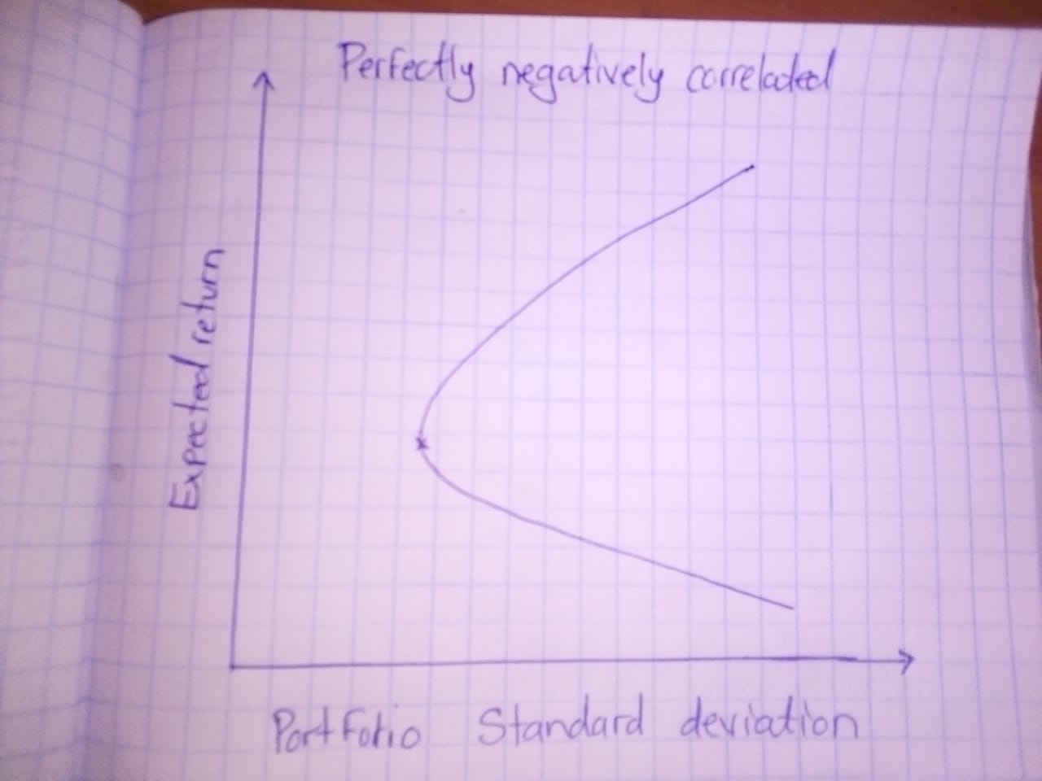
iii)
When an investor increases his or her allocation to one of the positively correlated projects the other will only be slightly affected or not at all since the projects are not perfectly correlated.
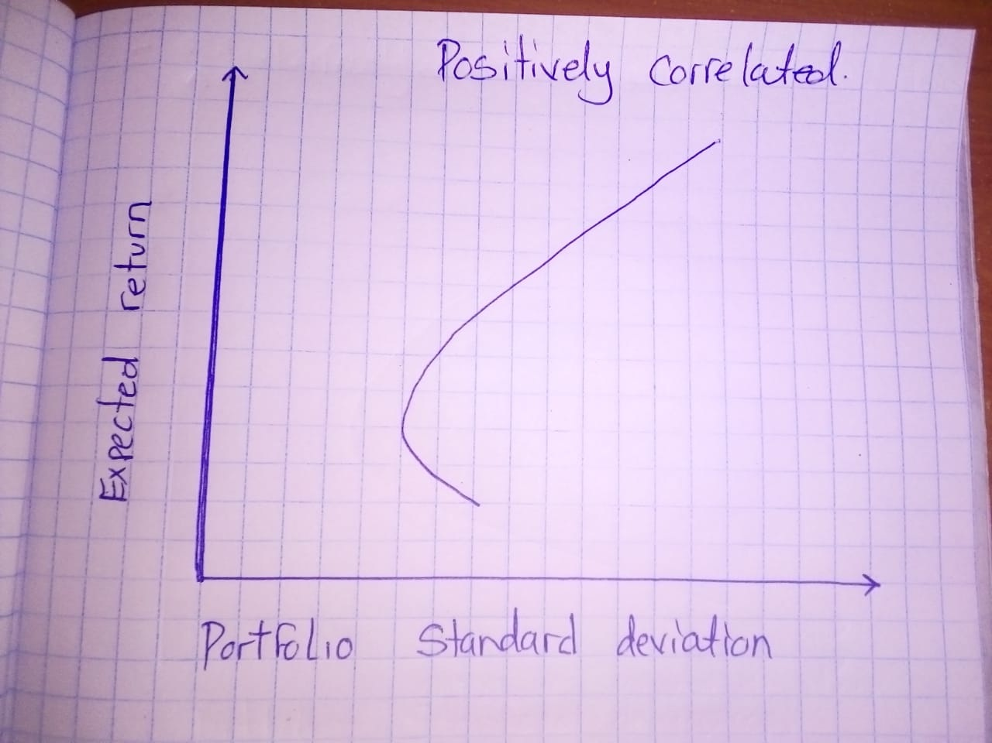
B)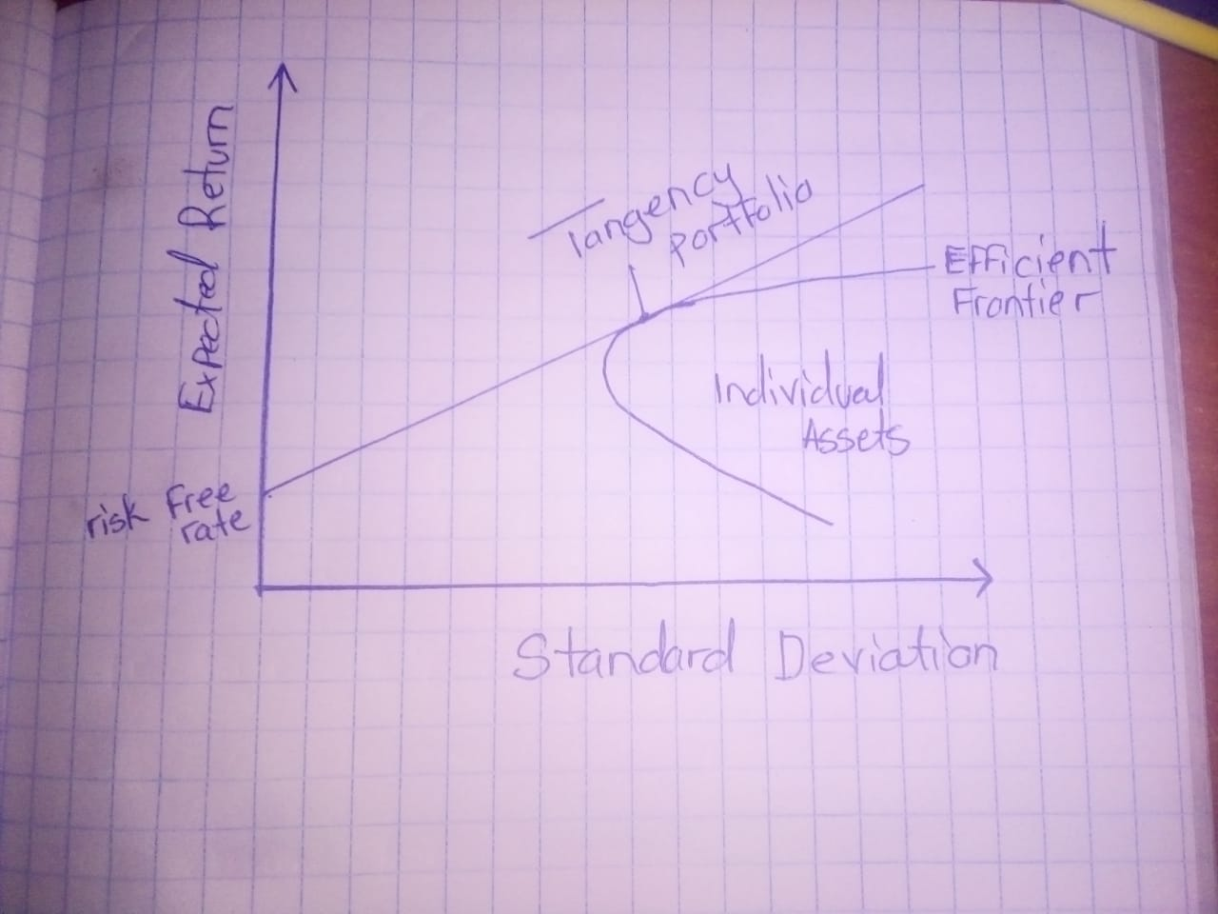
Initially the addition of more projects would increase the return on the portfolio but will start decreasing after reaching a certain point which is the capital market line.
C) Risk averse investors are likely to go for projects that are along the efficient frontier. Portfolios that cluster to the right of the efficient frontier are sub-optimal because they have a higher level of risk for the defined rate of return. Portfolios that lie below the efficient frontier are sub-optimal because they do not provide enough return for the level of risk.

2A) Two fund separation is a theory stating that under conditions in which all investors borrow and lend at the riskless rate, all investors will either choose to possess a risk-free portfolio or the market portfolio. It’s importance is that it’s extension tells us that when the uncertainty model is convex, an investor with quadratic utility and uncertainty aversion can separate her investment problem into two steps: First, find the portfolio of risky assets that maximizes the worst-case SR (over all possible asset return statistics); and then, decide on the mix of this risky portfolio and the risk-free asset, depending on the investor’s attitude toward risk. The risky portfolio is the TP corresponding to the least favorable asset return statistics, with portfolio weights chosen optimally.
b)
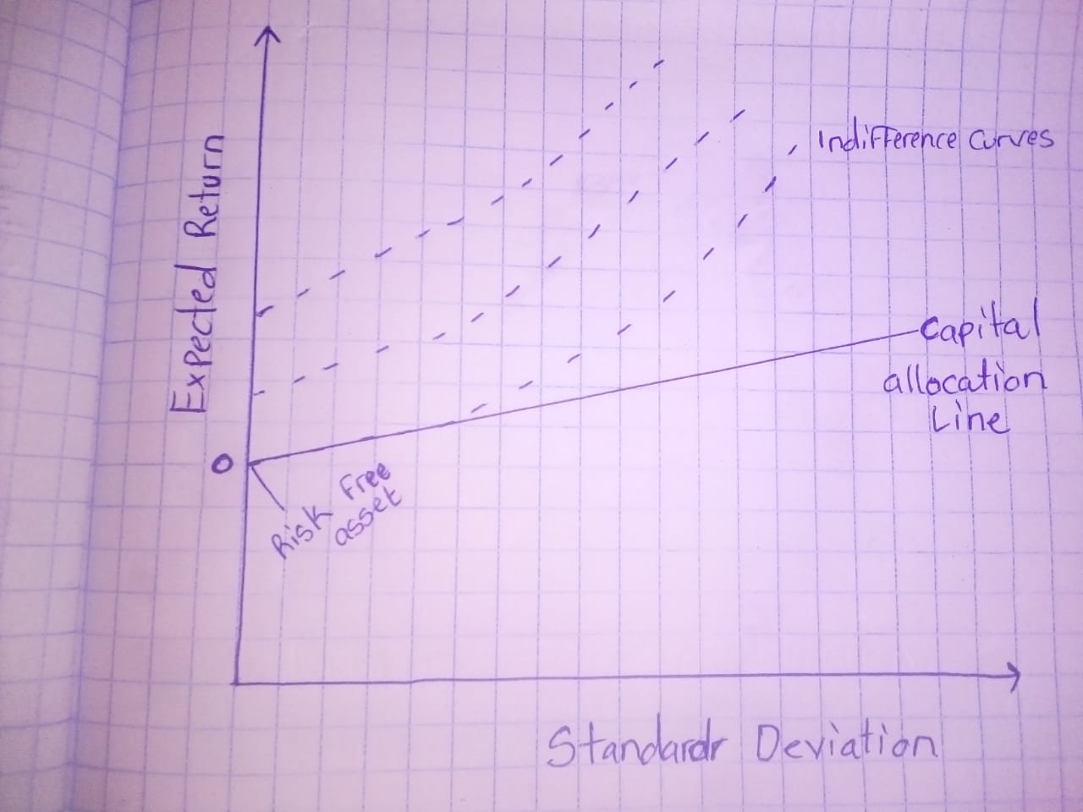

c) A risk averse investor is an investor who prefers lower returns with known risks rather than higher returns with unknown risks. Risk averse investors tend to perform better in capital markets since they go for investments with lower interest rates. Additionally they also critically evaluate the future performance of an investment before making any transactions; this protects them from suffering any huge losses.
d) No model miss-speculation-the two-step asset allocation process is based on the assumption that there is no model uncertainty or model miss-specification that is the input data or parameters like the mean vector and covariance matrix of asset returns are perfectly known. These input parameters are typically empirically estimated from historical data of asset returns, or from extensive analysis of various types of information about the assets and macro-economic conditions.
e) $beta=\frac{covariance}{variance}$
Covariance =0.3
Variance =0.2
0.3/0.2=1.5
Beta = 1.5
The stock is more risky than the market since the beta is greater than one.
3) A)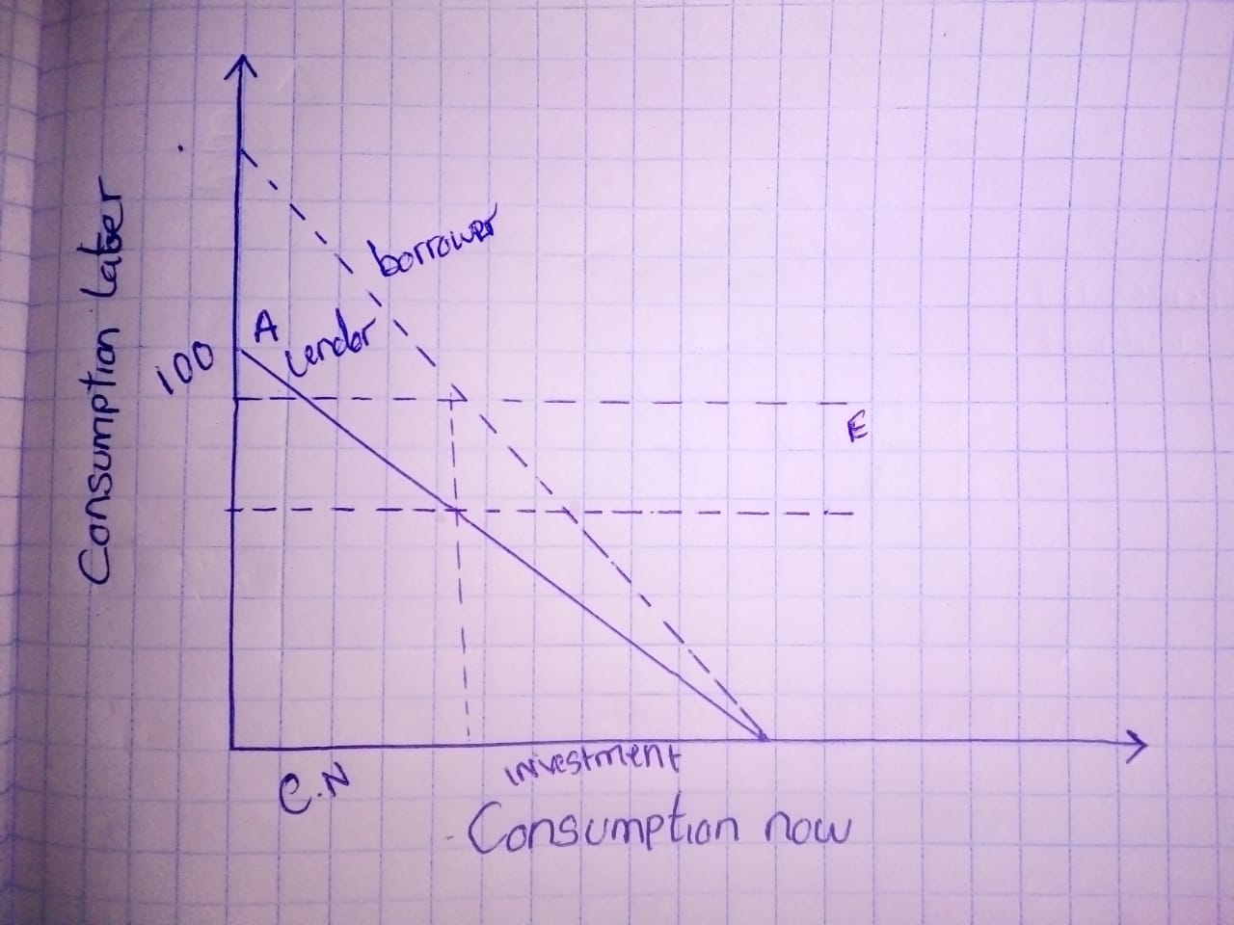

B) Investor’s optimal portfolio may be located at any point on line T_{b} - B (borrowing funds), may be located at any point on line C - T_{l} (lending funds), and may be located on the curve T_{l} - T_{b} , this is neither the lending nor borrowing.
In the above figure, CML is made up of C - T_{l} - T_{b} - B, that is a line segment (C - T_{l}), a curve segment (T_{l} - T_{b}), and another line (T_{b} - B). CML_{b} is slightly kinked as the borrowing rate is higher than the risk-free lending rate and small part of the concave efficient frontier is a segment of the CML_{b}

C) Securities Market line is a graphical representation of CAPM (Capital Asset Pricing Model).It Reflects levels of systematic risk of various Marketable Securities. The graphical representation of SML is based on the formula
Required Return = Risk-free rate of return + Beta [Market return - Rsk-free rate of return]
Where,
E (RI) = Required Return / Expected Return on Security
Rf= Risk Free Rate
E (Rm) = Market Return / Expected Return on Market Portfolio
Beta = Systematic Risk
The X axis Denotes Beta i.e. Systematic Risk or Market Risk
Y axis represents Required Rate of Return.
D) The Securities that lie above the Securities Market Line are undervalued because for a given amount of risk, they yield a higher return. The assets below the SML are overvalued because for a given amount of risk, they yield a lower return.
Alpha is the term used to describe manager's / strategies ability to generate return over and above of the market Return. Alpha is the excess return of an investment relative to the return of a benchmark. Alpha may be Positive or negative, depends on Active Investment.
Alpha = Investment return - Benchmark's Return
As per Security Market Line, Higher Alpha means Better Stock Selection and High Return on Portfolio.
Alpha in Security Market Line can be described as the gap between Expected Return on Market Portfolio and Risk free Return.
E) To understand the market perception, one needs to know that the actual return gives the meaning of actual return that will be yielded by holding a stock, and an expected return is the return that is expected by an investor. Market perceptions effect over the actual return by holding biases by the investors.
Investor's create market perception by showing herd-mentality at times by following a group of shareholder's opinions to sell/buy the stock which is set as an example of market perception, and this may affect over the demand and supply for a stock.

4) A)
I
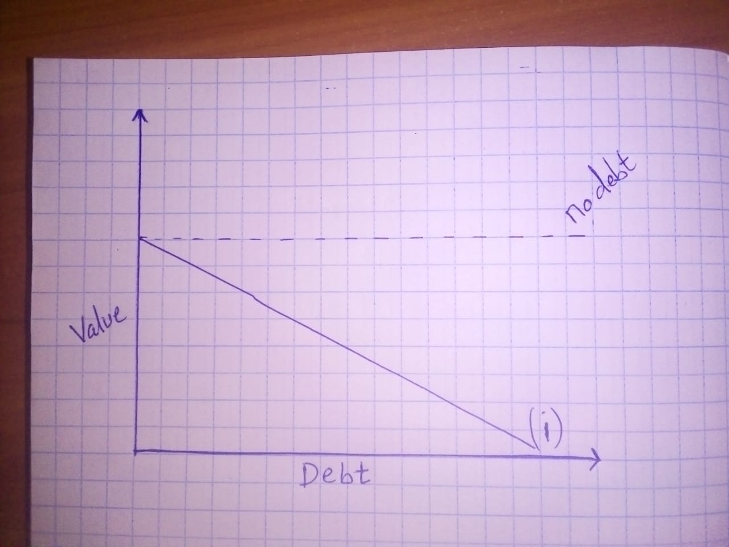
Ii
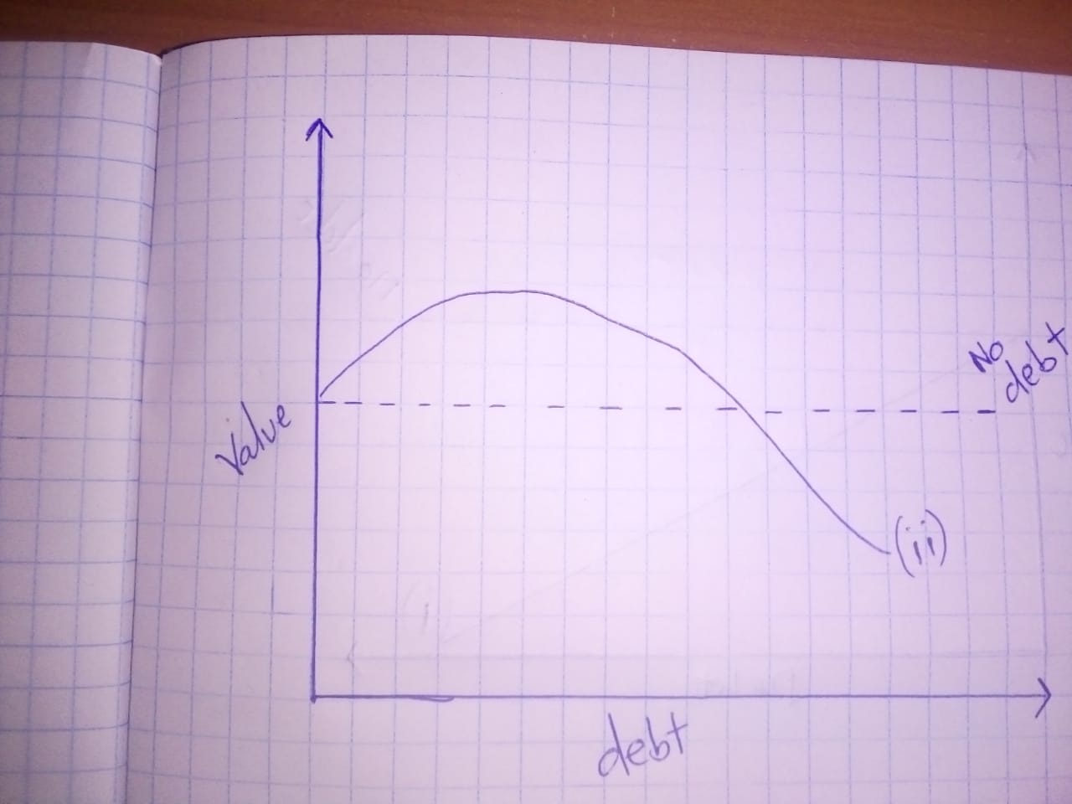

iii)
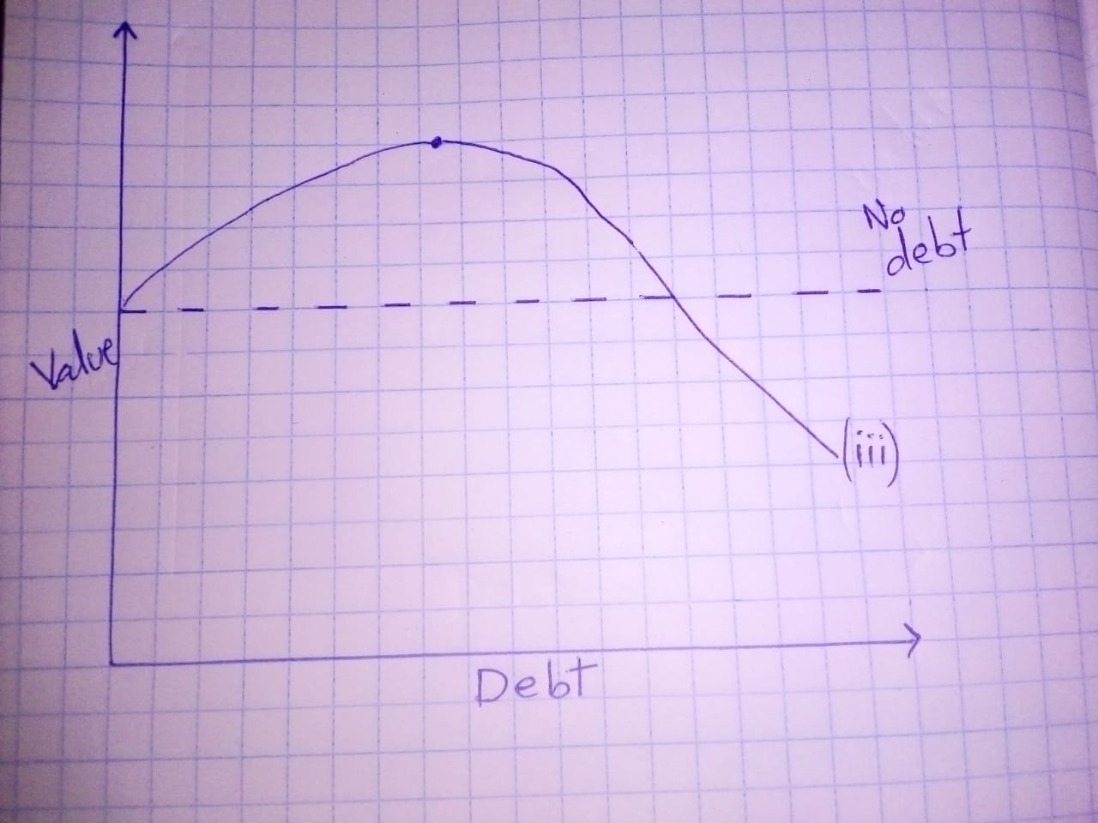
B) From the above we can conclude, if there is no tax then accumulating debt decreases value of firm. However if there is tax then up to a certain level of debt corporate can take benefit of interest costs and improve their value . But after a certain level the cost of debt servicing brings down the value of the firm. If the debts are risky implying higher interest costs initial tax benefits are higher but after the optimal level the costs increase faster thus depleting value. Similarly financial distress and bankruptcy costs deplete the value even faster.
C) Personally I think Scenario 3 is the most realistic as corporate debts carry a certain amount of risk and excess debt can lead to financial distress for any firm or company.
D)
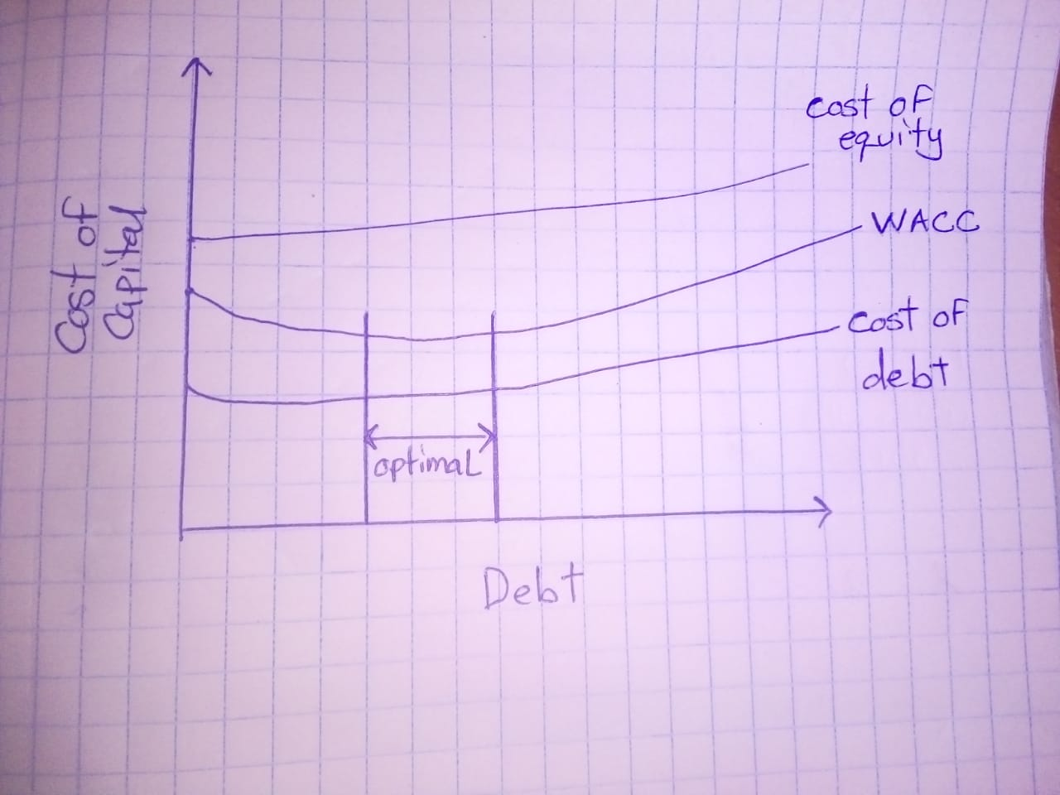

E) WACC is actually the lowest when there is an optimal mix of debt and equity; a certain amount of debt helps in tax benefits due to interest cost deduction and thus could be added to the capital structure. But beyond the optimal point it’s too costly to service the debt so costs outweigh the tax benefits.
5) A) WACC=WD*Kd+We*Ke
Where, Wd is weight of Debt, We is weight of equity, Kd is cost of debt, Ke is cost of equity.
Kd=4*(1-.03) %
=2.8%
Ke=4+6*1.2 (Formula=Risk free return+ Market risk premium* Beta)
=11.2%
WACC=.40*2.8+.6*11.2
=7.84%

B)
Years | 0 | 1 | 2 | 3 | 4
FCF | -216000 | 100000 | 75000 | 50000 | 25000
Present value @7.84% | -216000 | 92730 | 64491 | 39869 | 18485

NPV= -425
c) Firm should not invest in the project since NPV is negative.

D) Bu = Bl*1/ {1+D (1-t)/E}
Where Bu is unlevered beta, Bl is levered beta, D is debt, E is equity, and t is Tax rate
Bu=1.2*1/ {1+.4(1-0.3)/0.6}
Bu=0.818

E) New Beta=Bu (1+D (1-t)/E)
=0.818(1+0.5(1-0.3)/0.5)
=1.39
Ke=4+6*1.39
= 12.34
WACC=.5*2.8+.5*12.34
= 7.57%
F)
Years | 0 | 1 | 2 | 3 | 4
FCF | -216000 | 100000 | 75000 | 50000 | 25000
Present value @7.57% | -216000 | 92963 | 64816 | 40170 | 18671

NPV = 620
G) Firm should accept the project since NPV is positive.

6) A) some of the conditions where dividend policy payout ratio will be irrelevant include:
- When there are no taxes so that it can't make any difference on payment of dividend or capital gain on shares.
- Perfect capital market which means there is no floatation cost and transaction cost for security and all information related to market is publically available.
-When there is no risk involved with the project and there is certain return and investors do not have any expectations.
B) Asymmetric information means one party has better information in comparison to other which lead to difference making and transactions. When there is imbalance in market it can lead to its failure. Two Examples of asymmetric information are as follows: Real estate market where seller has more information than the buyer which can affect decision making. Sale of second hand cars, where sellers and buyer don't share complete information impacts decision making.
c) In case of real state asymmetric information can be reduced through providing complete details and disclosure with respect to property and by providing valuation certificate of registered rater by giving details of market rate of the property. In case of sale of second hand car asymmetric information can be reduced through providing warranty for the reliability of the car and providing car test facility.
D) Signaling means conveying some information about one party to another. Any change in security price or volatility in the market is a signaling effect of some information out in the signaling is corporate finance refers to use of some insider information for trading purposes which impact the buying and selling of security. In corporate finance signaling might either be used to make security buying or selling decisions depending on the information given out.

